**Bright Young Minds at Oasis**

Jane Boehr  
Nipawin Journal  
Thursday, June 25, 2015 12:23:57 MDT PM

<http://www.nipawinjournal.com/2015/06/25/bright-young-minds-at-oasis>

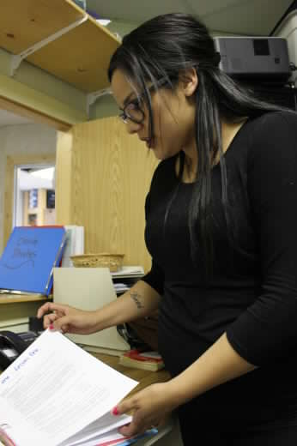

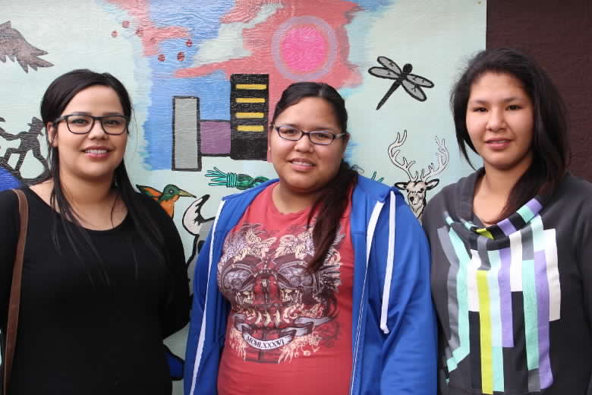

Raquel Chaboyer is o ne of the three new students working at the Oasis Centre this summer. She is originally from Cumberland House but has traveled across the province for her education. She holds a degree in Native Studies from La Ronge and is now working towards a degree in Social Work. Chaboyer has many skills that she will be tapping into at the Oasis, among them is a passion for working with youth and the ability to draft relevant policies for the centre's needs.

"I started off as Joy's [Hanson's] Executive Assistant last month. My duties were policy work, general policies and Joy wanted something more specific for the family support workers, [pertaining to] suicide prevention, child neglect etc".

As part of her research Chaboyer met with staff in Prince Albert at facility that's much like Oasis. She and her co-workers were trying to figure out the best way to draft policies for social issues should the need ever arise. With the policies now drafted she is able to focus on running the summer programming with the help of the other summer students and staff.

Chaboyer will be incorporating in the programme, "traditional time". The expertise of Oasis' cultural consultant Harriet Burns and Hilda Roberts will be employed in the hopes that the youth will learn something new that about their heritage.

"I have a schedule for up to 4 weeks [ready] for summer programming. Joy was impressed by the work that [Kayla] and I did. We're teaching lots of life skill and lessons [this summer] and some sexual health, mental health, health and well-being, those types of things.

Chaboyer says the programme is going to be aimed at youth because there aren't many options for young people in Nipawin between the ages of 12-18.

The two other summer students, Kayla Bear of Shoal Lake and Shania Umpherville from Red Earth will also be working directly with the youth. Chaboyer says she and Bear worked together to get the programming ready for the end of June.

"There will be 5 of us running the day-to-day operations, Kayla and myself [will be] doing most of the work throughout the week. [There will be] life skills, outings and then Harriet and Hilda will do more the traditional side of it. We're also doing Cree lessons. It will be an introduction to Cree, just the basics, [and] very simple words. We need to incorporate the traditional side to the program because the majority of the participants are First Nations."

Chaboyer says this week they will be asking young people at Oasis to attend the summer programmes. They are hoping for 12 -15 students ages 12 and up.

With roughly a year and half left in her education towards a degree in Social Work, Chaboyer will be taking 10 days to do a mandatory culture camp.

"It's 2 days class time and 8 days at Lucky Man First Nation.[There will be] traditional times, they will teach us a lot. In the fall I will be [back to school] fulltime in Prince Albert".

Chaboyer loves working with young people and hopes to secure a job with youth as soon as she graduates with her degree in Social Work.

"It's very important for them to have that connection with you. One thing they teach you in social work is to build a relationship with the people you are working with. That way they feel you're easier to talk to. [I look forward to] interacting with them, seeing what they're like and be some sort of role model to them. I think they are at a critical age now, being 12 years old, that's why I think this program is so good for them. We're going to be teaching them life skills and giving them information they may not get at home or at school and building a comfortable place for them. They love the Oasis, they love coming here".

The youth summer programming at Oasis will begin on June 29 and will run throughout the summer months. Registration is now open.